|  |  |  |  |
| --- | --- | --- | --- |
| **Roll No: 113** | **Name: Harshita Shetty** | **Div: B** | **Batch: B2** |

**Experiment No.05: Frequency Reuse**

**Aim:** To Implement Frequency Reuse Using Python.

**Theory:** Frequency Reuse is the scheme in which the allocation and reuse of channels throughout a coverage region is done. Each cellular base station is allocated a group of radio channels or Frequency sub-bands to be used within a small geographic area known as a cell. The shape of the cell is Hexagonal. The process of selecting and allocating the frequency sub-bands for all of the cellular base stations within a system is called **Frequency reuse or Frequency Planning. Salient features of using Frequency Reuse:**

* Frequency reuse improves the spectral efficiency and signal Quality (QoS).
* The frequency reuses classical scheme proposed for GSM systems offers protection against interference.
* The number of times a frequency can be reused depends on the tolerance capacity of the radio channel from the nearby transmitter that is using the same frequencies.
* In the Frequency Reuse scheme, the total bandwidth is divided into different sub-bands that are used by cells.
* The frequency reuse scheme allows WiMax system operators to reuse the same frequencies at different cell sites.

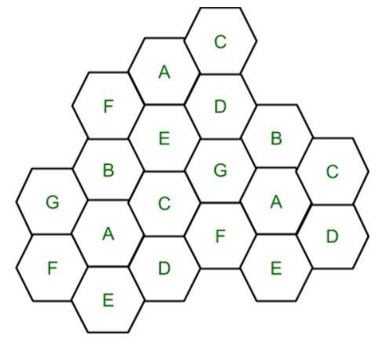

Cell with the same letter uses the same set of channels group or frequencies sub-band. To find the total number of channels allocated to a cell: S = Total number of duplex channels available to

use k = Channels allocated to each cell (k<S) N = Total number of cells or Cluster Size Then the

Total number of channels (S) will be,

S = kN

Frequency Reuse Factor = 1/N

In the above diagram, cluster size is 7 (A, B, C, D, E, F, G) thus frequency reuse factor is 1/7. N is the number of cells which collectively use the complete set of available frequencies is called a Cluster. The value of N is calculated by the following formula:

N = I2 + I*J + J2

Where I, J = 0,1,2,3… Hence, possible values of N are 1,3,4,7,9,12,13,16,19 and so on. If a

Cluster is replicated or repeated M times within the cellular system, then Capacity, C, will be, C = MkN = MS

In Frequency reuse, there are several cells that use the same set of frequencies. These cells are called Co-Channel Cells. These Co-Channel cells result in interference. So to avoid Interference cells that use the same set of channels or frequencies are separated from one another by a larger distance. The distance between any two Co-Channels can be calculated by the following formula:

D = R * (3 * N)1/2

Where R = Radius of a cell N = Number of cells in a given cluster

**Advantages:**

* Improved Spectral Efficiency: By reusing the same frequency in different geographic areas, spectral efficiency can be improved, enabling more efficient spectrum usage. ● Better Quality of Service: With the ability to reuse the same frequency in different cells, the interference between cells can be minimized, leading to a better quality of service.
* Cost-Effective: Frequency reuse can reduce the cost of building a cellular network since fewer frequency bands are required.

Scalability: Frequency reuse enables the network to be easily scaled by adding more cells as needed.

* Increased Network Capacity: Frequency reuse allows more cells to be served with the same amount of spectrum, resulting in increased network capacity.
* Scalability: Frequency reuse enables the network to be easily scaled by adding more cells as needed.

**Disadvantages:**

* Increased Interference: Frequency reuse can result in increased interference, particularly in areas where cells are closely spaced. This can reduce the quality of service and network capacity.
* Implementation Complexity: Frequency reuse requires careful planning to ensure that cells are appropriately spaced and that interference is minimized. This can make the implementation process more complex and time-consuming.
* Reduced Coverage: With the use of smaller cells to achieve higher capacity, the coverage area of each cell is reduced, requiring more base stations and infrastructure.

●

* Increased Power Consumption: Due to the use of smaller cells, more base stations are required, leading to higher power consumption and operational costs.
* Increased Network Cost: The cost of implementing a frequency reuse system may be higher due to the need for additional infrastructure and careful planning to ensure proper frequency reuse.

**Program:**

#!/usr/bin/python

from math import *

# import everything from Tkinter module from tkinter import *

# Base class for Hexagon shape class Hexagon(object): def __init__(self, parent, x, y, length, color, tags):

self.parent = parent self.x = x self.y = y

self.length = length self.color = color self.size = None self.tags = tags

self.draw_hex()

# draw one hexagon def draw_hex(self): start_x = self.x

start_y = self.y angle = 60 coords = [] for i in range(6):

end_x = start_x + self.length * cos(radians(angle * i))

end_y = start_y + self.length * sin(radians(angle * i))

coords.append([start_x, start_y]) start_x = end_x start_y = end_y

self.parent.create_polygon(coords[0][0],

coords[0][1], coords[1][0], coords[1][1], coords[2][0], coords[2][1], coords[3][0], coords[3][1], coords[4][0], coords[4][1], coords[5][0], coords[5][1], fill=self.color, outline="black", tags=self.tags)

# class holds frequency reuse logic and related methods class FrequencyReuse(Tk):

CANVAS_WIDTH = 800

CANVAS_HEIGHT = 650

TOP_LEFT = (20, 20)

BOTTOM_LEFT = (790, 560)

TOP_RIGHT = (780, 20)

BOTTOM_RIGHT = (780, 560)

def __init__(self, cluster_size, columns=16, rows=10, edge_len=30):

Tk.__init__(self) self.textbox = None self.curr_angle = 330 self.first_click = True self.reset = False self.edge_len = edge_len

self.cluster_size = cluster_size self.reuse_list = [] self.all_selected = False self.curr_count = 0 self.hexagons = [] self.co_cell_endp = []

self.reuse_xy = []

self.canvas = Canvas(self,

width=self.CANVAS_WIDTH, height=self.CANVAS_HEIGHT, bg="#4dd0e1")

self.canvas.bind("<Button-1>", self.call_back) self.canvas.focus_set() self.canvas.bind('<Shift-R>', self.resets) self.canvas.pack()

self.title("Frequency reuse and co-channel selection")

self.create_grid(16, 10) self.create_textbox() self.cluster_reuse_calc()

# show lines joining all co-channel cells def show_lines(self):

# center(x,y) of first hexagon approx_center = self.co_cell_endp[0] self.line_ids = [] for k in range(1, len(self.co_cell_endp)):

end_xx = (self.co_cell_endp[k])[0] end_yy = (self.co_cell_endp[k])[1]

# move i^th steps

l_id = self.canvas.create_line(approx_center[0], approx_center[1],

end_xx, end_yy) if j == 0:

self.line_ids.append(l_id) dist = 0 elif i >= j and j != 0: self.line_ids.append(l_id)

dist = j

# rotate counter-clockwise and move j^th step l_id = self.canvas.create_line(

end_xx, end_yy, end_xx + self.center_dist * dist *

cos(radians(self.curr_angle - 60)), end_yy + self.center_dist * dist * sin(radians(self.curr_angle - 60))) self.line_ids.append(l_id) self.curr_angle -= 60

def create_textbox(self): txt = Text(self.canvas,

width=80,

height=1,

font=("Helvatica", 12),

padx=10, pady=10)

txt.tag_configure("center", justify="center") txt.insert("1.0", "Select a Hexagon") txt.tag_add("center", "1.0", "end")

self.canvas.create_window((0, 600), anchor='w', window=txt)

txt.config(state=DISABLED)

self.textbox = txt

def resets(self, event): if event.char == 'R': self.reset_grid()

# clear hexagonal grid for new i/p def reset_grid(self, button_reset=False): self.first_click = True self.curr_angle = 330 self.curr_count = 0 self.co_cell_endp = [] self.reuse_list = [] for i in self.hexagons:

self.canvas.itemconfigure(i.tags, fill=i.color)

try:

self.line_ids except AttributeError:

pass

else: for i in self.line_ids: self.canvas.after(0, self.canvas.delete, i) self.line_ids = []

if button_reset:

self.write_text("Select a Hexagon")

# create a grid of Hexagons def create_grid(self, cols, rows):

size = self.edge_len for c in range(cols): if c % 2 == 0:

offset = 0 else:

offset = size * sqrt(3) / 2 for r in range(rows):

x = c * (self.edge_len * 1.5) + 50 y = (r * (self.edge_len * sqrt(3))) + offset + 15

hx = Hexagon(self.canvas, x, y, self.edge_len, "#fafafa",

"{},{}".format(r, c))

self.hexagons.append(hx)

# calculate reuse distance, center distance and radius of the hexagon def cluster_reuse_calc(self): self.hex_radius = sqrt(3) / 2 * self.edge_len self.center_dist = sqrt(3) * self.hex_radius

self.reuse_dist = self.hex_radius * sqrt(3 * self.cluster_size)

def write_text(self, text):

self.textbox.config(state=NORMAL) self.textbox.delete('1.0', END)

self.textbox.insert('1.0', text, "center")

self.textbox.config(state=DISABLED)

#check if the co-channels are within visible canvas def is_within_bound(self, coords):

if self.TOP_LEFT[0] < coords[0] < self.BOTTOM_RIGHT[0] \ and self.TOP_RIGHT[1] < coords[1] < self.BOTTOM_RIGHT[1]:

return True return False

#gets called when user selects a hexagon

#This function applies frequency reuse logic in order to

#figure out the positions of the co-channels def call_back(self, evt):

selected_hex_id = self.canvas.find_closest(evt.x, evt.y)[0] hexagon = self.hexagons[int(selected_hex_id - 1)]

s_x, s_y = hexagon.x, hexagon.y approx_center = (s_x + 15, s_y + 25)

if self.first_click:

self.first_click = False self.write_text(

"""Now, select another hexagon such that it should be a co-cell of

the original hexagon."""

)

self.co_cell_endp.append(approx_center)

self.canvas.itemconfigure(hexagon.tags, fill="green")

for _ in range(6):

end_xx = approx_center[0] + self.center_dist * i * cos(

radians(self.curr_angle))

end_yy = approx_center[1] + self.center_dist * i * sin(

radians(self.curr_angle))

reuse_x = end_xx + (self.center_dist * j) * cos( radians(self.curr_angle - 60))

reuse_y = end_yy + (self.center_dist * j) * sin( radians(self.curr_angle - 60))

if not self.is_within_bound((reuse_x, reuse_y)): self.write_text(

"""co-cells are exceeding canvas boundary.

Select cell in the center"""

)

self.reset_grid() break

if j == 0:

self.reuse_list.append(

self.canvas.find_closest(end_xx, end_yy)[0]) elif i >= j and j != 0:

self.reuse_list.append(

self.canvas.find_closest(reuse_x, reuse_y)[0])

self.co_cell_endp.append((end_xx, end_yy))

self.curr_angle -= 60

else:

curr = self.canvas.find_closest(s_x, s_y)[0] if curr in self.reuse_list: self.canvas.itemconfigure(hexagon.tags, fill="green") self.write_text("Correct! Cell {} is a co-cell.".format(

hexagon.tags)) if self.curr_count == len(self.reuse_list) - 1:

self.write_text("Great! Press Shift-R to restart")

self.show_lines()

self.curr_count += 1

else:

self.write_text("Incorrect! Cell {} is not a co-cell.".format(

hexagon.tags))

self.canvas.itemconfigure(hexagon.tags, fill="red")

if __name__ == '__main__':

print(

"""Enter i & j values. common (i,j) values are:

(1,0), (1,1), (2,0), (2,1), (3,0), (2,2)"""

)

i = int(input("Enter i: ")) j = int(input("Enter j: ")) if i == 0 and j == 0:

raise ValueError("i & j both cannot be zero") elif j > i:

raise ValueError("value of j cannot be greater than i") else:

N = (i**2 + i * j + j**2) print("N is {}".format(N)) freqreuse = FrequencyReuse(cluster_size=N) freqreuse.mainloop()

**GitHub Link:- https://github.com/shettyharshita/Mobile-Computing**

**Output:-**

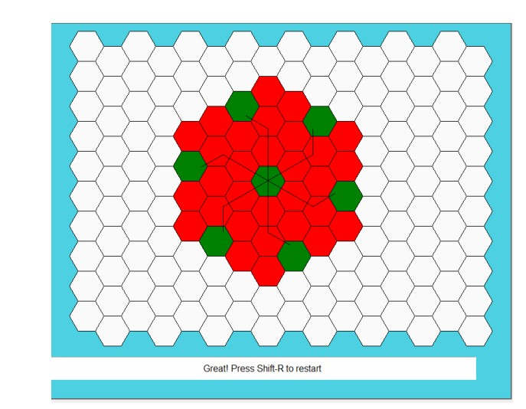

**Conclusion:-** The experiment was about Frequency Reuse which is successfully implemented and verified.